ACTIVITIES

Thematic Field: Policy / GDPR Practices
Title: Personal Data Protection according to the new General Data Protection Regulation (GDPR)
Last edit : 26/06/2018

Authors: CTIP – Greek School Network and Networking Technologies Directorate –eSafetyLabel+ Ambassadors Team

List of Activities
Reference | Title | Level
EL01.1_L1 | Introduction to personal data issues and to Privacy Policy through presentation/discussion | L1- Easy
EL01.2_L2 | The new General Data Protection Regulation (GDPR) and the Right to be Forgotten | L1- Easy
EL01.3_L3 | Designing of an interactive knowledge quiz about GDPR in Scratch Programming environment | L2- Medium

Notice: Before starting the implementation of the 3 proposed activities, students have to fill in a questionnaire, in order to evaluate any previous knowledge. After the completion of the 3 educational activities, the students fill in, again, the questionnaire, in order to evaluate the effectiveness of the whole procedure.

Activity 1: Introduction to personal data issues and to Privacy Policy through presentation/discussion

Level: L1- Easy
Duration: 45 mins (1 didactic hour)

Short description - Goals
In this educational activity, the purpose is to introduce the students into the basic concepts of personal data. Furthermore, the students get to know the significance of the implementation of Privacy Policy in every organization.
Goals
After the completion of the educational activity, the students will be able to:
- raise awareness about what personal data are
- raise awareness about what sensitive personal data are
- distinguish the privacy degree of each personal data
- raise awareness about the importance of personal data
- be aware of the existence of the Hellenic Data Protection Authority and its purpose
- be aware of the Data Privacy Policy and its importance to the citizens
- become more observant when they browse, concerning the Privacy Policy "fine print" that regulates the specific website
Process: Presentation-Discussion

Requirements – Instructions
The implementation of the activity requires:
- PC with Internet connection
- Projector
- https://www.youtube.com/watch?v=2oApceF5Br0 "Protecting our private life - We don't publish personal data - Police of Cyprus" (Last date of retrieval 13/05/2018) (Greek)
- https://tinyurl.com/yb7hjcej "Hellenic Data Protection Authority- Some guidelines for personal data" (Last date of retrieval 13/05/2018) (Greek)
- https://tinyurl.com/y9x3csb4 "You are not so much anonymous as you think-Video from the Norwegian Data Protection Authority (with Greek subtitles)" (Last date of retrieval 13/05/2018)
- Browsing in the Privacy Policy of Google and its products (Gmail, Youtube) (Last date of retrieval 13/05/2018)
- Α presentation in Greek from https://saferinternet4kids.gr/gdpr/ about personal data. (Last date of retrieval 25/06/2018)

Prerequisites
No previous knowledge.

Scenario
Description
The students watch the video from the Norwegian Data Protection Authority, https://tinyurl.com/y9x3csb4, as the introduction to the subject, and then, the teacher coordinates a discussion about what the students understood from the video and whether they have any previous knowledge, they share it through discussion. Afterwards, the teacher presents what private data are, sensitive private data, the privacy degree of personal data and their importance through the presentation from https://saferinternet4kids.gr/gdpr/, following the showing of the video of Cyprus police, https://www.youtube.com/watch?v=2oApceF5Br0. Next, the teacher introduces to the students the Hellenic Data Protection Authority, https://tinyurl.com/yb7hjcej. Since students know what private data are, they get introduced to Privacy Policy, which they find it in every website that uses private data. They browse in Google Privacy Policy, in order to become aware of the Privacy Policy "fine print".

Conclusions
The students raise awareness of Data Privacy, an issue that some of them believed that possessed it. After the presentation and the discussion, the teacher will be able to evaluate whether the students "conquered" the knowledge, in order to continue with the next activity.
By the end, the students will be
- able to know where their private data are used for
- more observant and skeptical

The educational activity can be implemented in the context of the school lesson "ICT Applications" and/or in the context of the Data Privacy Day http://www.dpa.gr/portal/page?_pageid=33,123785&_dad=portal&_schema=PORTAL (Last date of retrieval 13/05/2018)

In "WebWeWant" handbook, there is a corresponding lesson plan, the WebWeWant, 5.2. PrivaSee - Privacy, my most precious possession http://www.webwewant.eu/documents/10180/23883/FINAL+HANDBOOK+FOR+EDUCATORS.pdf/a728fc8c-bf86-4ea9-a0ba-10f25c9d0949 , (Last date of retrieval 24/06/2018)

ACTIVITY 2 The new General Data Protection Regulation (GDPR) and the Right to be Forgotten

Level: L1- Easy
Duration: 45 mins (1 didactic hour)

Short description - Goals
In this educational activity, the purpose is to introduce the students into the new General Data Protection Regulation (GDPR), which is valid since 25/05/2018, learn about Cookies and their use, and the Right to be Forgotten, that all EU citizens have.
Goals
After the completion of the educational activity, the students will be able to:
- raise awareness about the new General Data Protection Regulation (GDPR)
- distinguish their digital obligations and rights
- become aware of the expansion of the "private data" concept, according to the GDPR
- raise awareness about the way the organizations save and use personal data
- raise awareness about the options that they have about the control of their personal data
- develop collaborative learning through creating a word cloud
- raise awareness about cookies, their use and how to control them
- become more observant and skeptical about pop-up windows that ask for personal data
- become more observant and skeptical about the use of their personal data
- become aware of their right to be forgotten and how they can use it
Process: Presentation-Discussion and activity with the use of Web2.0 tool for the word cloud

Requirements – Instructions
The implementation of the activity requires:
- PC with Internet connection
- Projector
- https://www.microsoft.com/el-gr/rethink-IT-security/GDPR/default.aspx "Browsing the new General Data Protection Regulation" (Last date of retrieval 13/05/2018) (Greek)
- Web 2.0 application https://worditout.com/ for the generation of a word cloud (Last date of retrieval 13/05/2018)
- What Cookies are and how we can control them
  - https://support.google.com/accounts/answer/61416?co=GENIE.Platform%3DDesktop&hl=el (Last date of retrieval 27/06/2018)
  - https://saferinternet4kids.gr/wp-content/uploads/2018/05/cookies-per-page.pdf (Last date of retrieval 27/06/2018)
- https://tinyurl.com/y8oaujfp "The Right to be Forgotten" (Last date of retrieval 13/05/2018)
- 7) Α presentation in Greek from https://saferinternet4kids.gr/gdpr/ about GDPR. (Last date of retrieval 27/06/2018)

Prerequisites
Implementation of the previous educational activity EL01.1_L1 "Introduction to personal data issues and to Privacy Policy through presentation/discussion".

Scenario
Description
After the implementation of the previous educational activity, the students have the required knowledge to get informed about what GDPR is and its impact on their personal data. The teacher analyses the presentation about GDPR from https://saferinternet4kids.gr/gdpr/, and afterwards, he shows to them the following figure about the age of consent in European countries about the use of social networks and they discuss about it.
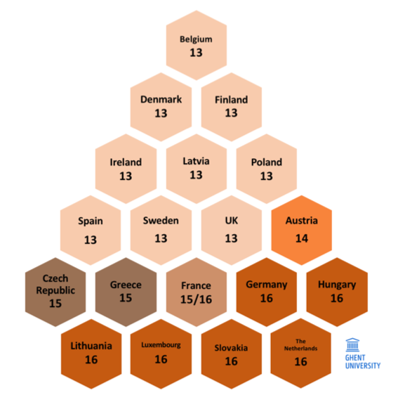
Figure 1: The age of consent in Europe

Afterwards, the teacher discuss with the students about the 8 principles that rules data protection, as shown in below figure.

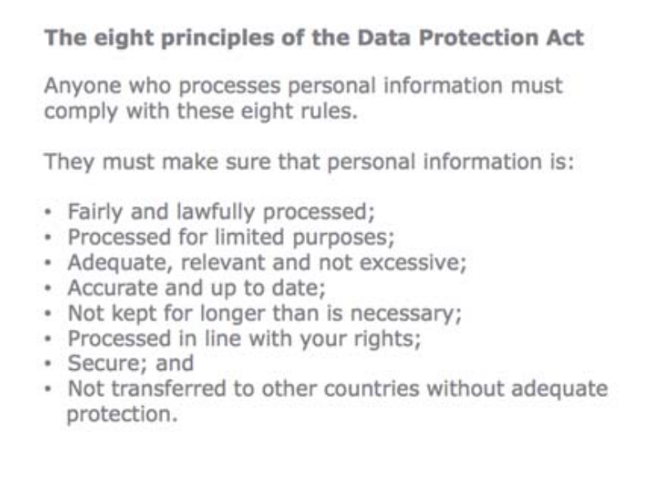
Figure 2: 8 principles of Data protection
Next, the teacher separates students into groups and assign to them to generate a word cloud with the most basic concepts of GDPR. They use the Web2.0 tool, https://worditout.com/ and for saving their cloud they can use the email account of the teacher-if they don't have theirs. The word cloud is saved as image and they will use it in the following educational activity. Afterwards, the students learn about cookies, their use and about the pop-up windows. https://saferinternet4kids.gr/wp-content/uploads/2018/05/cookies-per-page.pdf https://support.google.com/accounts/answer/61416?co=GENIE.Platform%3DDesktop&hl=el
Finally, students are getting informed about the Right to be forgotten, https://tinyurl.com/y8oaujfp

Conclusions
The students raise awareness about what GDPR is about and how it protects them. They learn about their digital rights and obligations and they realize that the concept “private data” is expanded. They learn how the organizations store and use their private data and that they have the control of their private data. They learn to use the Web2.0 application https://worditout.com/ and finally, they learn about the Right to be Forgotten that they have.

The educational activity can be implemented in the context of the school lesson "ICT Applications" and/or in the context of the Data Privacy Day http://www.dpa.gr/portal/page?_pageid=33,123785&_dad=portal&_schema=PORTAL (Last date of retrieval 13/05/2018)

Optional activity for students: If there is the potential, the students may watch the movie “The circle” with Emma Watson and Tom Hanks, a movie about the threat on data privacy because of social media. If part of the students watch the movie, there could be, afterwards, a constructive discussion about data privacy.

Activity 3: Designing of an interactive knowledge quiz about GDPR in Scratch Programming environment

Level: L2- Medium
Duration: 180 mins (4 didactic hours)

Short description - Goals
The specific educational activity is the third and last part of a 3-educational-activity packet about data privacy and GDPR. The students, separated into groups, will have to collect data and combine them in order to create an interactive quiz about data privacy and GDPR, in Scratch programming environment. The students have to combine knowledge from the two previous educational activities, in order to form the questions for the quiz.
Goals
After the completion of the educational activity, the students will be able to:
- develop critical thinking , combining previous knowledge
- develop collaborative learning, through working into groups
- better understand data privacy and GDPR issues
- reflect on their own online behavior
- familiarize themselves with Coding concepts
Process: Coding with Scratch

Requirements – Instructions
The implementation of the activity requires:
- PC with Internet connection
- Projector
- Scratch version 1.4 preferably (because it has Greek version and it can be transformed into the newer version, 2.0, through the online editor) https://scratch.mit.edu/
Scratch is a visual programming language targeted primarily at students. Using Scratch, users can create online projects and make them into anything by coding with simple blocks. Developed by the Lifelong Kindergarten group at the MIT Media Lab, the service is designed to help children (ages 8 and up) learn to imagine, reason with common sense, and work with computers. The user can use the stage area, featuring the results (i.e., animations, full-screen also available) and all sprites thumbnails listed in the bottom area. The stage uses x and y coordinates. There are many ways to create personal sprites and backgrounds. First, users can draw their own sprite manually with "Paint Editor" provided by Scratch. Second, users can choose a Sprite from the Scratch library that contains default sprite, user's past creations, a picture using a camera, or clip art.

Prerequisites
- Implementation of the two previous educational activities, EL01.1_L1 "Introduction to personal data issues and to Privacy Policy through presentation/discussion" and EL01.2_L2 “The new General Data Protection Regulation (GDPR) and the Right to be Forgotten”.
- Previous experience of programming-being familiar with Programming concepts

Scenario
Description
The first didactic hour, the students’ groups, under the guidance of their teacher, form the questions for the quiz, according to the knowledge gained from the previous educational activities.
The second didactic hour, the students start creating the quiz, which is continued during the third didactic hour. If 2 hours are not enough for the creation of the quiz, then the teacher will continue for another hour. The fourth didactic hour, the students test their programs and evaluate the results. If needed, they make changes. The teacher assess students’ effort and make comments.

Conclusions
After the completion of this educational activity, the students:
- raise awareness about GDPR and data privacy
- raise awareness about their digital rights and obligations
- familiarize themselves with Programming concepts
The educational activity can be implemented in the context of the school lesson "ICT Applications" and/or in the context of the Data Privacy Day http://www.dpa.gr/portal/page?_pageid=33,123785&_dad=portal&_schema=PORTAL (Last date of retrieval 13/05/2018) or as “Creative project”.

Copyright Notice:
This work is licensed under the Creative Commons Attribution-Noncommercial 3.0 License. To view a copy of this license, visit http://creativecommons.org/licenses/by-nc/3.0/ or send a letter to Creative Commons, 171 Second Street, Suite 300, San Francisco, California, 94105, and USA. The work must be attributed by attaching the following reference to the copied elements: “Copyright © Members of the eSL+ project, 2017”. See http://www.esafetylabel.eu/ for details of the eSL+ project. Using this document in a way and/or for purposes not foreseen in the license, requires the prior written permission of the copyright holders. The information contained in this document represents the views of the copyright holders as of the date such views are published.

Funding
Co-funded by the Erasmus+ of the European Union. Call 2017, Strategic Partnerships for school education, Key Action 2 – Cooperation for Innovation and the Exchange of Good Practices, Project Code 2017-1-EL01-KA201-036242.

