**SELF-EVALUATION WORKSHEET**

|  |
| --- |
| **Thematic Field:** Practices  **Title:** Evaluating Online content  **Last edit:** 20/06/2018 |

**Authors:** CTIP – Greek School Network and Networking Technologies Directorate –eSafetyLabel+ Ambassadors Team

# Choose the correct answer.

**1. Choose the sentence which states a fact.**

1. Coffee is a brewed drink prepared from roasted coffee beans, which are the seeds of berries from the Coffea plant.
2. Coffee is delicious.
3. Coffee makes you less hungry.
4. Coffee makes you stay awake.

**2. Choose the sentence which states an opinion.**

1. Green apples are fruits.
2. Green apples contains fibers.
3. Green apples are more delicious than red apples.
4. Green apples are in season in autumn.

**3. Fact or Opinion? Choose the sentence which is incorrect.**

1. Facts can be proved by doing a research.
2. A fact is a statement that is consistent with [reality](https://en.wikipedia.org/wiki/Reality) or can be proven with [evidence](https://en.wikipedia.org/wiki/Evidence).
3. An opinion is not always true and can’t be proven.

# The majority's opinion is always correct.

**4. Observe the image below and choose the sentence which states a fact.**

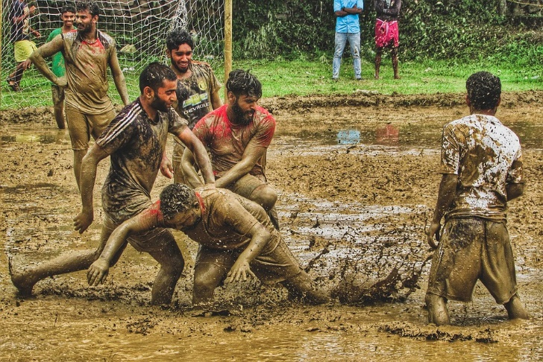

1. Those two men are helping the third one to stand up.
2. Those two men are forcing the third one to fall down.
3. Some bystanders are deriding instead of helping.
4. Their clothes are dirty.

**5. How to spot a hoax?**

1. The post motivates people to share/spread it.
2. There is no information about the author/creator of the post.
3. The names and people cited in hoaxes often have gaps in their history. Usually, characters’ last name is either missing or invalid.
4. All the above.

**6. How to spot fake news headline?**

1. Extensive use of characters like exclamation mark (!!!)
2. Extensive Use of capital letters.
3. Claims to reveal the truth that the others try to cover up.????
4. All the above.

**7. Observe the image below. Which of the following headlines states what really happened?**

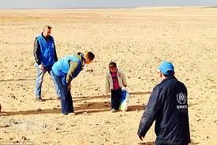

1. Here 4 year old Marwan, was crossing desert alone carrying his dead mother's clothes, found by UNHCR staff.
2. Here 4 year old Marwan, who was temporarily separated from his family, is assisted by UNHCR staff to cross.
3. Here 4 year old illegal immigrant get arrested by UNHCR staff.
4. Here 4 year old terrorist was crossing desert alone carrying a bag with explosives.

**8. Observe the image below. Which of the following headlines would get more clicks? (More options are correct)**



1. Here 4 year old Marwan, was crossing desert alone carrying his dead mother's clothes, found by UNHCR staff.
2. Here 4 year old Marwan, who was temporarily separated from his family, is assisted by UNHCR staff to cross.
3. Here 4 year old illegal immigrant get arrested by UNHCR staff.
4. Here 4 year old terrorist was crossing desert alone carrying a bag with explosives.

**9. What is the reason for that article to be published?**

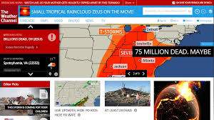

1. To inform the public about mass disasters and how to react in this case.
2. To entice users to click on the article. It’s a click-bait.
3. To help people finding [their way back to God](https://communitychristian.org/celebration-generosity/thenewthingteam/helping-people-find-their-way-back-to-god/).
4. To reveal the truth that the others try to cover up.

**10. You are reading the following headline “He slept with a red onion around his neck: when he woke up he witnessed a miracle!” What do you think it really happen to this man?**

1. He got  [rid of Acne once and for all](https://www.rd.com/health/beauty/get-rid-of-acne/).
2. He got healed from cancer.
3. He saw Jesus Face on onion’s surface.
4. His bed sheets smelt awful.

**11. Choose the click-bait headline.**

1. What Could Possibly Even Happen, My Goodness?!
2. From Burkina to Zimbabwe, U.S. aid cuts squeeze family planning services.
3. [Meghan Markle, Prince Harry make first official appearance as newlyweds](http://www.foxnews.com/entertainment/2018/05/22/meghan-markle-prince-harry-make-first-official-appearance-as-newlyweds.html).
4. Facebook's Zuckerberg apologizes to EU lawmakers over data leak.

**12.** **Where is most likely to see this photo?**



1. In an obesity medicine article.
2. In an Ad for diet pills.
3. In an article about the will power.
4. In an Ad for swimsuit.

**13. You are reading the following news on the net: “Category 6? If hurricane Irma becomes the strongest hurricane in new history, it could wipe entire cities off the map”.**

1. You read it out of curiosity and share it with others.
2. You don’t even read it but you share it, just to show that you are on line.
3. You send the link to all of your friends on social media. Everyone must be informed.
4. It is a click-bait, so you just ignore it and you do not share it with the others.

**14. The image on the right is retouched. Choose the one that is not considered to have a negative impact.**

1. Deception of the public.
2. Unrealistic teenage beauty standards.
3. Teen depression and anxiety.
4. Motivation to learn Photoshop.

**15. Photoshoped or not? The image below is …**

1. 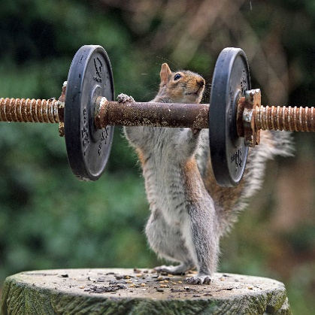Real
2. Photoshoped

**16. Photoshoped or not? The image below is …**

1. 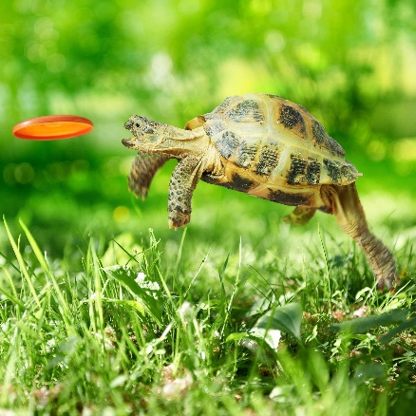Real
2. Photoshoped

**Copyright Notice:**

This work is licensed under the Creative Commons Attribution-Noncommercial 3.0 License. To view a copy of this license, visit <http://creativecommons.org/licenses/by-nc/3.0/> or send a letter to Creative Commons, 171 Second Street, Suite 300, San Francisco, California, 94105, and USA. The work must be attributed by attaching the following reference to the copied elements: “Copyright © Members of the eSL+ project, 2017”. See <http://www.esafetylabel.eu/> for details of the eSL+ project. Using this document in a way and/or for purposes not foreseen in the license, requires the prior written permission of the copyright holders. The information contained in this document represents the views of the copyright holders as of the date such views are published.



**Funding**

Co-funded by the Erasmus+ of the European Union. Call 2017, Strategic Partnerships for school education, Key Action 2 – Cooperation for Innovation and the Exchange of Good Practices, Project Code 2017-1-EL01-KA201-036242.