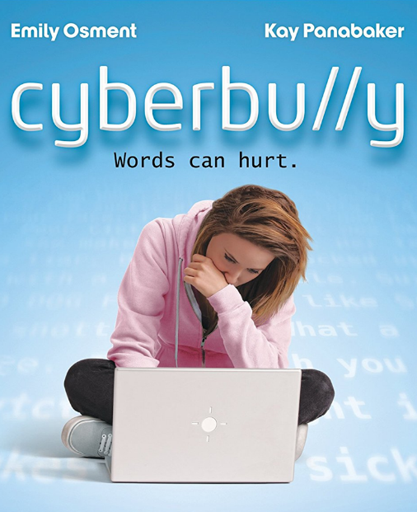

**Exploration Guide**

of the movie

***Cyberbu//y***

**Links**

https://www.youtube.com/watch?v=hbjjjL0qEIg

https://www.youtube.com/watch?v=ghPcYqn0p4Y

https://www.youtube.com/watch?v=oR40SOwwruc

Virtual Threat

How to Act?

**Technical Specs**

**Title:** Cyberbu//y

**Year:** 2011

**Director:** Charles Binamé

**Movie Lenght:**122 min

**Main Cast**

Emily Osment

(character: Taylor Hillridge)

Kay Panabaker

(character: Samantha Caldone)

Kelly Rowan

(character: Kris Hillridge)

Jon McLaren

(character: Scott Ozsik)

**Music**

Emily Osment - “Drift”

Sia - “Breathe Me”

Kim Taylor - “Build You Up“

**Synopsis**

The film *Cyberbully* – *Words can hurt*, directed by Charles Binamé, portrays the story of a teen student that receives a laptop on his birthday. After creating a social network profile, she experiences a complete life change as she becomes a victim of cyberbullying.

Made by K7 to K9 students of Escola Básica 2/3 de Quinta da Lomba, Barreiro, Portugal.

**WORDS CAN HURT**



Replace this insert with a crossword table in your own language/L2, containing relevant/appropriate words regarding cyberbullying and this movie.

Students may propose more words and create new matrices.

Now let’s watch the film *Cyberbu//y – Words can hurt.*

**Before the Film**

*Cyberbullying* – concept

Group of threats, constraints and other acts of intimidation or humiliation continuously performed upon one person, considered weaker or fragilized, using the internet.

In *Priberam dictionary*

**3.** Did you like the film? Tell us two reasons that justify your previous answer. What is your favorite scene?

**4.** How would you act if you’ve been in Taylor Hillridge’s situation?

**5.** What do you think of Jean-Paul Sartre’s sentence “Violence, however it may be presented, is always a defeat”, after seeing this movie?

**2.** In the crossword table below, mark the words related to concepts analyzed on the film.

**1.** How do these words relate to what the character (Taylor Hillridge) experiences during the film?

**After the Film**

This is an excerpt of one of the music’s lyrics.

“I am

Just another number

Stack me up I’ll crumble

And drift along

I am

Just another nothing

Light me up I’ll fall in”

“Drift”