ACTIVITIES

Thematic Field: Practices
Title: Screentime
Last edit: 16/07/2018

Authors: CTIP – Greek School Network and Networking Technologies Directorate –eSafetyLabel+ Ambassadors Team

List of Activities
Reference | Title | Level
EL03.1_L1 | Introduction to understanding the time we generally spend in front of the monitors using brainstorming / discussion conceptual map | L1- Easy
EL03.2_L1 | Introduction to understanding the time we generally spend in front of the monitors using brainstorming / discussion wordart creation | L1- Easy
EL03.3_L2 | Dealing with screentime (stage play or role playing) | L2- Moderate
EL03.4_L3 | Making of a multi-choice quiz related to screentime (hotpotatoes) | L3- Advanced

Introduction to screentime issues
Level: L1- Easy
Duration: 45 mins (1 teaching hour)

Short description - Goals
Purpose: This activity attempts to introduce students to basic concepts and issues concerning the time we generally spend in our lives in front of monitors, either for serious purpose (study) or for fun.
Objectives: At the end of the activity, students will be able to determine how much time we can sit in front of a screen, associating addictive behaviors to monitors that surround us at home and the content they display, to recognize the results of the extended time we spend sitting in front of the screens, to reflect on their own behavior and the time they spend for fun or study in front of a screen so as to help themselves, and others, to learn strategies to properly manage time for play, lessons, fun, relaxation and food.
Method: sharing ideas / brainstorming / presentation / conceptual map and discussion.

Requirements – Instructions
The realization of the activity requires:
- A4 paper
- Whiteboard/chalkboard

Scenario
Description
It can be implemented as a brainstorming discussion with students, exchanges of views, etc. The brainstorming may contain words and concepts related to the words "Screen" and "Time", such as TV, PC, laptop, tablet, mobile, cinema, ..., day, hour, night, night, message, chat, game, minecraft, roblox, fortnite, ....
The teacher writes the word "screen" and "time" at a central point of the whiteboard (see Figure 1) and asks the children to come up with relevant words. Then, he creates a conceptual map.
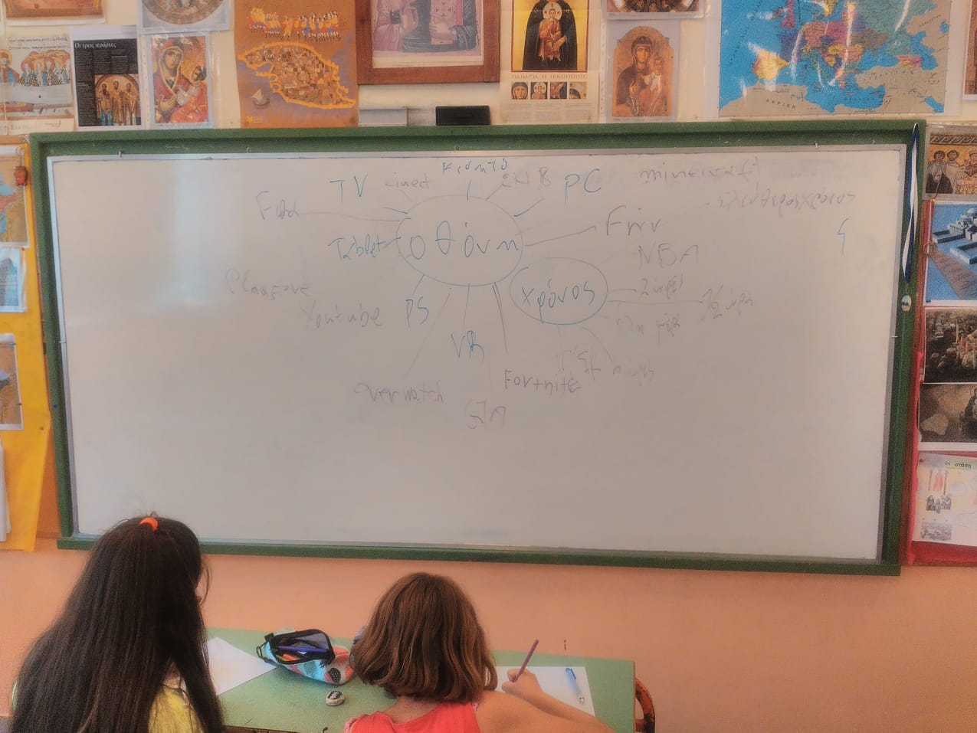
Figure 1
The teacher may hand out to each student a piece of A4 paper to design his favorite screen (see Figure 2) and the game he is playing or the activity he performs on it.
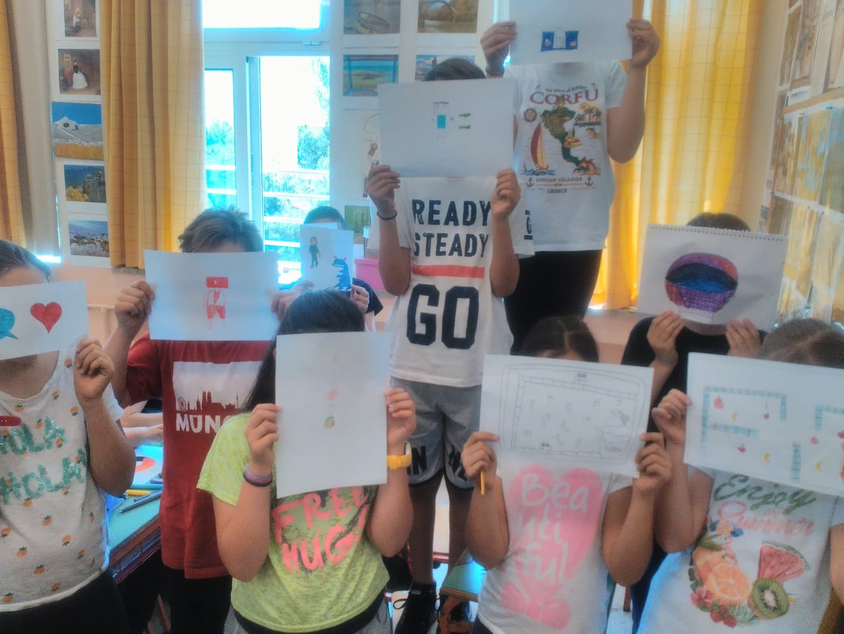

Then, after a discussion, children can show ways they use to avoid either being dragged away by their favorite game or creating addictive behaviors and sitting in front of the screen rather than doing their lessons, playing in the yard - park – playground or eating with their parents at the family table.
The scenario can be implemented in one (1) or even two (2) teaching hours depending on the extent the teacher wishes to give on issues that may be related to excessive screen time and electronic devices consumption (internet bullying, cheating, sexting,...). Additionally, it can be applied within a Health Education lesson, Creative Work within a related topic, to introduce students to the time they are sitting in front of the screens and to be a burden for further discussion.
Proposal: Making minor changes, the presentation and the scenario, could also be applied to training / parenting activities.

Conclusions
Conclusions can be derived from the results of the discussion, participation and interest of students.
In the end, depending on the time left, an activity can be done to assess the degree of achievement of the purpose and the specific objectives of the activity.
A questionnaire in the form of quizzes or a form with questions related to the subject of the presentation / discussion can be completed by the students.

Introduction to screentime issues
Level: L1- Easy
Duration: 45 mins (1 teaching hour)

Short description - Goals
Purpose: This activity attempts to introduce students to basic concepts and issues concerning the time we generally consume in our lives in front of monitors, either for our work or for fun.
Objectives:
At the end of the activity, students will be able to determine how much time we can consume sitting in front of a screen, associating behavioral dependencies on monitors that surround us at home and the content they display, to recognize the results of the extended time we spend sitting in front of the screens, reflecting on their own behavior and the time they consume for fun or work in front of a screen so as to help themselves but also the others, learn strategies to properly manage time for play, lessons, fun, relaxation and food.
Method: sharing ideas / brainstorming / wordart presentation and discussion.

Requirements – Instructions
The realization of the activity requires:
1) PC with internet access, projector
2) Sign up at https://wordart.com

Scenario
Description
It can be implemented in the form of brainstorming discussion with students, exchanges of views, etc. The brainstorming may contain words and concepts related to the words "Screen" and "Time", such as TV, PC, laptop, tablet, mobile, cinema, ..., day, hour, night, night, message, chat, game, minecraft, roblox, ....
The teacher signs in the account at https://wordart.com, writes the words "screen" and "time" and asks children to come up with related words. Then, he creates a wordart (see Figure 3).
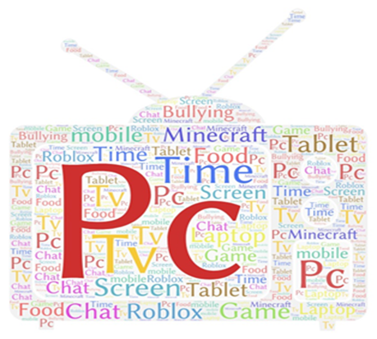
Figure 3

The teacher or a student makes the application settings for the desired result.
Then, after a discussion, children can show ways they use to avoid either being dragged away by their favorite game or creating addictive behaviors and sitting in front of the screen rather than doing their lessons, playing in the yard - park – playground or eating with their parents at the family table.
The scenario can be implemented in one (1) or even two (2) teaching hours depending on the extent the teacher wishes to give on issues that may be related to excessive screen time and electronic devices consumption (internet bullying, cheating, sexting, ...). Additionally, it can be applied within a Health Education lesson, Creative Work within a related topic, to introduce students to the time they spend sitting in front of the screens and to be a burden for further discussion.
Proposal: Making minor changes, the presentation and the scenario, could also be applied to training / parenting activities.
Related References:
• https://wordart.com/blg6z2j607jt/screentime2
• https://wordart.com/lxz0sfrbs88t/screentime1
(Last date retrieved, 28/06/2018)

Conclusions
Conclusions can be derived from the results of the discussion, participation and interest of students.
In the end, depending on the time left, an activity can be done to assess the degree of achievement of the purpose and the specific objectives of the activity.
A questionnaire in the form of quizzes or a form with questions related to the subject of the presentation / discussion can be completed by the students.

Dealing with screentime (stage play or role playing)
Level: L2- Moderate
Duration: 90 mins (2 teaching hours)

Short description - Goals
Purpose: This activity aims to introduce students to basic concepts and issues related to screentime use of digital devices in a less behavioral approach than EL03.1_L1.
Objectives:
At the end of the activity, students should be aware of the issue of excessive and unrestricted use of digital devices, be able to recognize data on the use of digital devices, relate behaviors to screentime consumption (recognize behaviors and roles, from the side of the adult, parent, teacher, grandfather, who sets the terms and rules, etc.), understand concepts regarding the rules related to the digital devices screentime, recognize the effect that their excessive use may have in our health, recognize the negative effects for the school study, know what they should do and what they should not do in case they need help in the absence of an adult.
Method: relevant work / working groups / presentation of results in plenary and discussion.

Requirements – Instructions
The realization of the activity requires:
1) PC and projector.
2) Creation of a relevant role-playing game in which students will be taking on parent, teacher, and child roles in order to define an agreement for the correct use of digital device sreentime.

Scenario
Description
The pupils are divided into groups under the guidance of the teacher and create and play a small play that lasts only a few minutes, in which everyone takes on a role, eg someone will take on the role of a parent, others (6-7) the role of the child, the role of the teacher and others (eg one older brother).
Each group will create a fiction, prepare a short play of a few (4-8) minutes, each of them arguing to support his position, to see the pros and cons of each one's view, to collide with opinions and then to synthesize them for an outcome. The fiction combined with the role play game achieves the confrontation of the different perspectives of the subject and the processing of any alternative views by children themselves. This method develops the empathy of the group members as it directly concerns the interests of the pupils. Emphasis should be placed on how to deal with the issue, how to find a common acceptable solution, to see what everyone should do (as a student, classmate / friend, teacher, parent, older brother) to deal with excessive and uncontrolled use of digital devices.
Proposal: With minor changes on the acting and scenario, it could also be applied to teacher training activities or parenting activities to trigger a discussion on school policy, internal rules, precautions, interventions, and dealing with relevant phenomena.

Conclusions
Conclusions can be derived from the results of the discussion, students’ participation and interest.
In the end, depending on the time left, an activity can be done to assess the effectiveness and the individual objectives of the activity.
A questionnaire in the form of quizzes or a form with questions related to the subject of the presentation / discussion can be completed by the students.

Making of a multi-choice quiz related to screentime (hotpotatoes)
Level: L3- Advanced
Duration: 130 mins (3 teaching hours)

Short description - Goals
Purpose: This activity attempts to focus on screentime use of digital devices, through the creative expression of students as well as the study and the creation of a relevant game or quiz.
Objectives:
At the end of the activity, students will be actively engaged in an activity of creating an artifact (quiz or play) through a simple platform to create an interactive quiz, such as “hotpotatoes”. Beyond the obvious benefits of their engagement in the process of programming and collaborating with their classmates, they will be in the process of collecting data, studying, exploring and discovering data related to dealing with issues of excessive use of their digital devices, as they will have been assigned to them and have chosen to work on a relevant topic. Thus, they should look for, modify appropriately and create their own questions and corresponding images and enter them into the program. In any case, through their engagement in the process, students are expected to deepen on time management issues concerning digital devices, be able to recognize behaviors that can lead them to overuse their device, recognize the effect they may have abusing their time to the detriment of their study, playing with friends in their neighborhood, eating or resting.
Method: Creating an artifact related to the proper screentime use of electronic / digital devices, through a programming tool, in groups, according to the interests of the students, in a computer lab.

Requirements – Instructions
The realization of the activity requires:
1) Computer laboratory with internet access and projector
2) Presentation of the tool to be used to create the artefact (game or quiz) and appropriate preparation (eg, program installation).
“HotPotatoes” is an open source software consisting of six authoring tools enabling us to create and easily write interactive multiple-choice, short-answer, jumbled-sentence, crossword, matching/ordering and gap-fill exercises for the World Wide Web. The exercises are displayed in the classroom as html, and each student responds to them either having access from the local classroom network (if they are previously stored) or from an internet connection (if stored on a suitable web server).
3) Familiarization with the selected tool must be prioritized so that students focus on the creation of the artifacts related to the core subject of the activity.
4) It would be advisable to have preceded activities related to the issues of screentime management of electronic/digital devices, so that students are aware of the case and have an incentive to engage in the creation of an artifact.
Related References:
- https://hotpot.uvic.ca/
- http://users.sch.gr/salnk/didaskalia/Hotpotatoes.htm
(Last date retrieved, 28/06/2018)

Scenario
Description
In the beginning, there is a discussion on the topic of time management that students use their electronic and digital devices to be aware of the issue. In addition, Hotpotatoes courses for familiarization with the tool should be prioritized so that students focus on creating the artifact related to the subject of the activity.
Students are divided into groups, under the guidance of the teacher and based on their interests and the type of artifact they want to create. After appropriate preparation, students choose between interactive multiple-choice exercises, short answers, jumbled-sentence, crossword, matching/ordering, and gap-filling exercises (see Figures 4 and 5). There will be a discussion on the basic purpose of creating an artifact that will sensitize those who use/test/play it on device management issues, emphasizing on the recognition of the behavior and roles of those involved in overuse and neglection of study, walk, friends, changing the time of eating and sleeping.
Exercises are standard Web pages using XHTML code for the screen, and JavaScript for interactivity. The value of Hotpotatoes programs lies mainly in the ability of the teacher and students to easily create many different types of web-based exercises (html).
Students can then access the exercises either in the school lab if they are stored on the local network or connected to the internet if they are stored on a suitable web server.
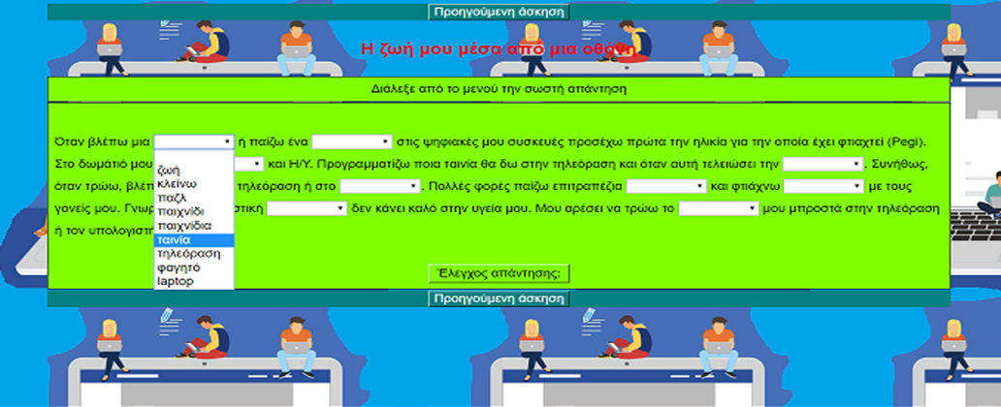
Figure 4

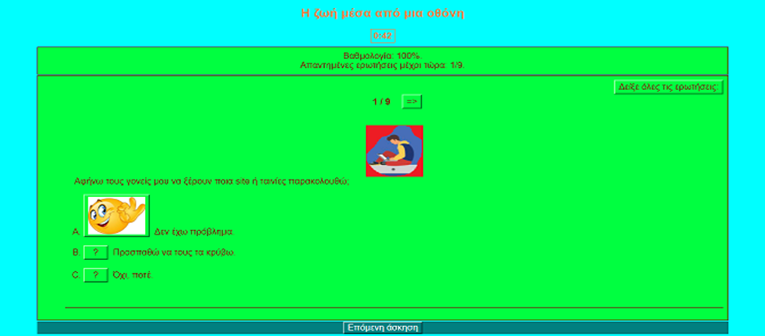
Figure 5

Conclusions
Conclusions can be derived from the students' own creations.
After the implementation and testing of the exercises that have been set up, a plenary debate can be held for extensions, possible improvements and, above all, the level of achievement of the objective of raising awareness about digital content management issues.

Copyright Notice:
This work is licensed under the Creative Commons Attribution-Noncommercial 3.0 License. To view a copy of this license, visit http://creativecommons.org/licenses/by-nc/3.0/ or send a letter to Creative Commons, 171 Second Street, Suite 300, San Francisco, California, 94105, and USA. The work must be attributed by attaching the following reference to the copied elements: “Copyright © Members of the eSL+ project, 2017”. See http://www.esafetylabel.eu/ for details of the eSL+ project. Using this document in a way and/or for purposes not foreseen in the license, requires the prior written permission of the copyright holders. The information contained in this document represents the views of the copyright holders as of the date such views are published.

Funding
Co-funded by the Erasmus+ of the European Union. Call 2017, Strategic Partnerships for school education, Key Action 2 – Cooperation for Innovation and the Exchange of Good Practices, Project Code 2017-1-EL01-KA201-036242.

